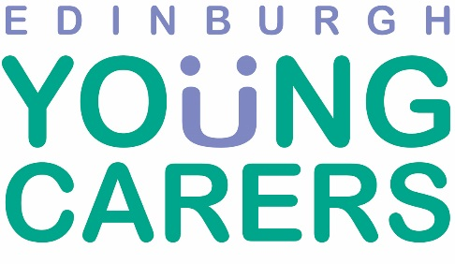

Drug and Alcohol Service

Vacancy for Permanent Part-time (21 hrs) Young Carer Development Worker

Starting Salary: £26,272 pro-rata

Edinburgh Young Carers is seeking a suitably experienced and qualified applicant to join its Drug and Alcohol Support Service in developing and providing high quality support to young carers in Edinburgh between the ages of 5 and 25 years, who care for someone with problematic drug and/or alcohol use.

The postholder will work alongside colleagues to increase the Service’s effectiveness, identify hidden young carers, develop and provide support and increase our knowledge and understanding of the needs of young carers who are caring for someone with problematic drug and/or alcohol use.

The candidate will be expected to have proven experience of working with children and young people and working with people affected by drug and alcohol difficulties, with a sound understanding of Child Protection issues and relevant qualifications. We seek experienced professionals committed to improving the lives of young carers.

Organisation Profile:
Edinburgh Young Carers Service is a voluntary organisation working with and on behalf of young carers throughout Edinburgh. We are one of the largest and most well established independent young carers organisations in Scotland. We have a strong commitment to the rights of children and young people.

For further details and an application pack, please visit the Vacancies section on our website at www.youngcarers.org.uk/vacancies or contact info@youngcarers.org.uk.

Closing date & time: Monday 15th February 2021 at 12pm
Interview date: Thursday 25th February 2021

