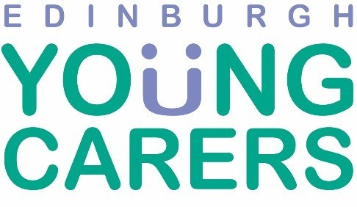
Board of Directors – Vacancy

About Edinburgh Young Carers
Edinburgh Young Carers is a sector-leading body and operates to help young people with caring responsibilities across Edinburgh. We are committed to giving young people the very best support and opportunities via a range of high quality and person-centred services. We ensure a rights-based approach to our work: young carers are actively involved in shaping our development – from raising awareness of their needs to helping us deliver change through campaigning efforts.

About this Opportunity
The Board meets regularly (generally every six weeks on a Monday evening from 5.30pm - 7.30pm). There are times when you will be asked for extra commitment for specific projects; agreed through negotiation. At present, the Board has two sub-committees; one focusing on quality and the other on finance matters. On average, the applicant can expect to spend between 1-2 days per month on EYC issues (including attendance at Board meetings).
As with all our Board roles, this is a voluntary position. All reasonable expenses incurred in carrying out the tasks of a Board member (including travel) will be reimbursed. We will provide full training for the role including a supportive induction as well as the opportunity to attend a Board meeting prior to appointment.
This is an excellent and rewarding opportunity for an individual with the right mix of experience and passion, who is looking for a meaningful way to help improve the lives of young carers across Edinburgh.
Currently, our Board has members with a range of skills and backgrounds including: social work; I.T.; business and corporate; finance; the charitable and public sectors and child protection. The Board works well together with members supporting each other as well as employed staff and the senior management team.

Skills & Experience
We are looking for someone with a commitment to providing high quality support to young carers. The principal area of specialism for the successful candidate at present will be knowledge in the education sector, preferably at seondary level. That said, anyone with relevant skills in other disciplines will also be given active consideration.

Meeting Arrangements
Board Meetings take place at the offices of Edinburgh Young Carers, Norton Park, 57 Albion Road, Edinburgh EH7 5QY. During the COVID-19 pandemic, Board Meetings are being held digitally via Zoom.
Additional Factors - Accessibility Details
Wheelchair Access: Available Disabled Toilet: Available
Minimum Age: Volunteers must be at least 18 years of age.
If you are interested in this amazing opportunity, please contact our main office number on 0131 475 2322 for an application form, or alternatively you can access a copy of the application from our website.

